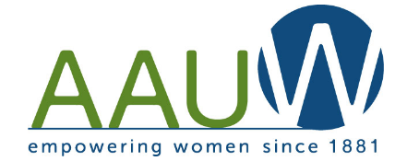
AAUW Luncheon – Recycling Demystified
Saturday, November 16, 2019
11:30 AM – 2:30 PM

The Garage Restaurant
202 W. Main St., Northville
(Use parking lot to west of restaurant and enter side door)

We invite AAUW members to bring spouses, friends, neighbors to this informative meeting. Our knowledgeable speaker is award winning Tracy Purrenhage from the Resource and Recycling Authority of Southwest Oakland County (RRRASOC). Please join us to learn what we all can do to recycle more effectively!

All reservations and payments are required prior to October 25th, 2019. The meal is $32 per person. Please select the main course each attendee prefers.

Name(s) of attendees and meal selection for each named attendee:
_____________________________________________________________________________________

Phone # of main contact: ________________________________________________________

Meal Choices:
- Chicken Cutlet Piccata (Simmered lemon, parsley, caper berry and grilled artichoke heart)
- Italian Chicken Trapani (Marsala wine, cream, seared field mushrooms)
- Hot Ruby Quinoa (Kale, butternut squash, mushroom, white bean, blistered tomato and onion)
- Vegetarian Ravioli (Chef’s selection, pesto cream sauce, garden vegetables)
Each meal includes mashed potatoes and seasonal vegetables, a green salad, bread and butter, coffee, tea and ice tea. Soft drinks and alcoholic beverages will be an additional charge.

Please make checks ($32 for each attendee) payable to AAUWNN. Please mail to:
AAUWNN, PO Box 511, Northville, MI 48167 ATTN: Emily Doubler (no later than Oct. 25th)

Payments can also be made to our website (www.aauwnn.org) via PayPal with a follow-up email to Emily Doubler confirming attendee names and menu selection for each attendee.

Questions: Please contact Emily Doubler at eajw1976@gmail.com or 248-854-7862

